Benchmarking Jev vs the LLMs: Are Decision Models Ready for eDiscovery?
How many H100s does it take to play SimCity? How big an LLM do you need to label an email? Today's frontier models have parameter counts in the trillions, and can pass the bar exam, write working software and hold a conversation in fifty languages. TypeSafe AI's position is that, for many classification and automation tasks, using an LLM is like crushing an ant with a sledgehammer. On September 15, TypeSafe AI released Jev, a model designed specifically for large-scale classification and automation tasks. TypeSafe calls Jev a System One model; we will mostly call it a decision model: instead of generating text, it takes a document and a typed question and returns one of the answers you offered, with a probability attached.
Here is the short version: zero-shot, with criteria written once and handed to every model in the same words, Jev landed at 78.5% recall and 79.6% precision on eleven TREC 2016 topics, mid-pack on F1 against the frontier LLMs, while running 9 to 23 times faster and 8 to 107 times cheaper. One composed configuration we call Facets got to 89% recall at 75% precision, within a few points of Sonnet 5. The rest of this article is how we got those numbers and what we think they do and don't mean.
Jev achieves similar levels of intelligence on System One tasks compared to existing LLMs, while being two orders of magnitude faster and more efficient. While Jev gives up string generation, it’s optimized for structured outputs and can’t hallucinate. — TypeSafe AI, launch post, Sep 15, 2026
Before your hype detector goes off, consider that there may be something to this. The race to vibe the coolest Jev v LLM bakeoff has produced some compelling examples. The following comes from: https://typesafe.ai
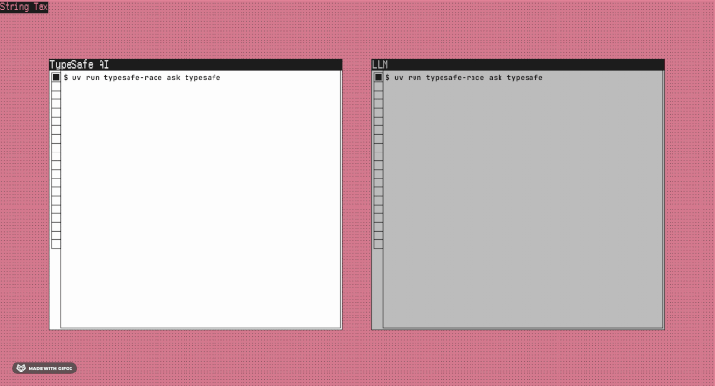
But you've heard "better, faster and cheaper" before, and we're not sure vibe-GIFs hold up in court yet. It may be the world's fastest sock sorting machine, but can it make complex legal determinations at scale? It's 2026 and we know better than to judge a model by hype alone. But let's also not be impulsively dismissive. There are a lot of things faster and cheaper than LLMs that can't do what LLMs can do, and the question is whether Jev is one of them; whether it's Jev or another model, we know the technology is evolving in one direction, and we should be prepared for disruption. So let's find out if there's a there there.

What does "good enough" mean for document review?
As most readers of this page know, in complex litigation, document review involves lawyers making legal determinations against large populations of documents that ultimately determine what gets produced to an opposing party or regulator. Traditionally, lawyers use platforms like Relativity to apply case-specific rules for responsiveness, privilege and other issues, which wind up as labels in a database. So we are talking about labeling emails (and other types of electronically stored information or ESI), but we're not talking about triaging help desk tickets.
With typical review populations in the millions, human review has given way to various iterations of technology assisted review (TAR), including supervised and unsupervised ML and LLM-based workflows. Courts began accepting TAR in 2012, when Judge Andrew Peck approved its use in Da Silva Moore v. Publicis Groupe, and by 2015, in Rio Tinto v. Vale, he could write that it was "now black letter law that where the producing party wants to utilize TAR for document review, courts will permit it." Since then, TAR adoption has climbed, as has the use of sample-based validation to certify results and defend its use. Today, most large cases involve an agreement between parties that allows for the use of TAR, sometimes subject to transparency and validation disclosures. While there is no legal precedent for the "minimum passing rate" for a TAR project, a 70-80% recall floor is a common rule of thumb.

Enter the LLMs
In the last two years, LLM-powered document review has come on the scene as an alternative to traditional TAR models. Today, all leading eDiscovery platforms offer LLM-based document review, some with built-in statistical validation. While the engines differ, LLMs essentially slot into a TAR 1 workflow: the model is configured up front, applied to the whole population in a single pass, and validated with a sample; the practical difference is that the configuration step is prompt iteration rather than a human-labeled training set. That is how "TAR 1 Reference Model: An Established Framework Unifying Traditional and GenAI Approaches to Technology-Assisted Review" (The Sedona Conference Journal, vol. 25, 2024) by Tara Emory, Jeremy Pickens and Wilzette Louis frames it: GenAI is a new engine inside the same defensible TAR 1 process. At least one court has now taken the same view. In Schulte v. LinkedIn Corp., No. 22-cv-00237-HSG (LB) (N.D. Cal. June 30, 2026), Magistrate Judge Laurel Beeler treated LinkedIn's use of Relativity aiR, a generative AI review tool, as a form of TAR under the parties' existing ESI protocol, subject to no more or less scrutiny than a traditional TAR workflow. As a result, most practitioners apply the same "rule of thumb" recall floor of 70-80% to LLM-based review.
To be clear, if you're a lawyer conducting a review for production, whether by humans, an LLM or Jev, there is more to consider than recall and precision. The obligation under the Federal Rules is a reasonable inquiry (Rule 26(g)) and a process proportional to the needs of the case (Rule 26(b)(1)), and the Sedona Principles leave the choice of method to the responding party (Principle 6). That means weighing cost, timing, the risk profile of what is missed, privilege and confidentiality handling, defensibility of the workflow and how you will validate and document it, not a single accuracy number. Likewise, if you're a data scientist evaluating a new AI model, there's more to think about than recall and precision.

Experimental setup
Each email was sent, with its headers, together with a short matter-background paragraph and the criteria for all eleven topics in a single request, and each model returned a label and a probability for every topic. We compared Jev 1.13 (model id jev-1.13.0, the only version available) against six commercial LLMs and one open-weight model run locally: Haiku 4.5, Sonnet 5, GPT-5.6 Luna and Terra, Gemini 3.5 Flash-Lite and 3.8 Flash, and Gemma 3 12B. Gemma is the odd one out: it is open-weight and we ran it ourselves on a single rented A100, so its speed and cost reflect our hardware rather than a vendor's service. We report its recall and precision but leave it out of the speed and cost comparisons. We scored every model on five measures:
- Recall: % of relevant documents the model correctly marked as relevant
- Precision: % of documents the model marked as relevant that are actually relevant
- Speed: median latency to score one document
- Cost: $ per 100,000 documents
- Stability: How often a model will produce a different output given identical inputs
We chose to use TREC 2016, since it's well known in the legal industry, with ground truth labeled by a panel of NIST assessors. Also, TypeSafe has said that it generates its own training data and does not train on customer data (its privacy policy commits that it "will not train or fine tune any artificial intelligence or machine learning models on your prompts or other Input"), so there is no reason to think the Bush emails are in Jev's training set. Training-data contamination (the model having seen these public emails during training) may, however, influence results for the frontier LLMs.
We had each model review each email against eleven of TREC 2016's 34 topics. The topics are Jeb Bush-era Florida government subjects, and they range from the crisp (Movie Gallery, Bottled water, Condominiums) to the sprawling (George W. Bush, Marketing, Faith-based initiatives, the 2000 recount, Medicaid reform, the lost foster child Rilya Wilson, and two topics that share the acronym NRA: the National Rifle Association and non-resident aliens). We ran a twelfth, Eminent domain, and dropped it: NIST's own second assessors agreed with the first on as little as 7% of its re-judged documents, which is a reminder that "ground truth" in review is itself a judgment call.
The topic criteria every model saw were written from NIST's topic sentence and allowed exactly one round of iteration, done on a separate calibration sample of 668 emails that is not part of the evaluation sample described below. After that pass they were frozen and given to every model identically. Nobody tuned wording to a model.
For the LLMs, that meant a system prompt ("You are a document review classifier working on an eDiscovery matter ... Return only the structured result. Do not explain."), the request text, "responsive means" / "not responsive means" descriptions, and a JSON schema forcing a label and a probability.
Jev does not take a prompt in that sense. TypeSafe exposes three question types, which they call primitives, and you pick the shape of the answer:
- Noul: a yes/no question; the answer is a probability that the answer is yes. "Is this document responsive to the following request for production? [topic text]", with the responsive / not-responsive descriptions as the true/false criteria. This is our default.
- Choice: pick one option from a list; the answer is a probability for each option and a confidence. Same question, options "responsive" and "not_responsive".
- Score: a position on a scale whose levels you describe; we used five, from "Clearly not responsive to the request" to "Clearly responsive to the request", and divided by four to get a probability.
- Facets (our construction, not theirs): where a topic has distinct parts, ask one Noul per part and take the highest probability. For Faith-based initiatives, the topic is "grants or other initiatives in Florida to offload social services to so-called faith-based agencies"; the facets are "Does this email concern grants or funding for faith-based agencies to provide social services in Florida?" and "Does this email concern any other Florida initiative, program, partnership or policy to have social services delivered by faith-based or religious organizations?" The penumbra is the second question: a pastor's prison re-entry program is responsive; a prayer breakfast is not.
In every case the model marks the email responsive when the probability is 0.5 or higher; we did not tune that cutoff. One property of Jev matters for what follows: it cannot answer outside the labels or the scale you gave it. There is no text to parse, no "as an AI model" refusal, no invented category. It can be wrong, but it cannot be off-topic.
From the collection of about 290,000 emails we drew a stratified evaluation sample of 3,016: for each topic, 100 emails NIST judged relevant, plus 1,000 judged not relevant and 1,000 drawn at random, excluding the calibration set (in the full collection, fewer than one email in a hundred is relevant to most of these topics).
One consequence worth stating plainly: the evaluation set is enriched. About a third of these emails are responsive to at least one topic, versus well under a tenth in the raw collection. That is because most of the sample draws on emails NIST assessors had actually judged, and assessors only saw emails that TREC participants' retrieval systems had surfaced as candidates, much the way a keyword cull surfaces candidates in a typical review workflow; the 1,000 random emails are the exception. Recall does not care about this; precision does, because every extra non-responsive email is another chance for a false positive. Read the precision figures below as precision on a culled set of similar richness, not on a raw collection.
Two more limitations of the test itself are worth stating before the results. First, the criteria got their one round of refinement on the calibration sample by reading shared misses with Jev and Gemini 3.5 Flash-Lite, so if the criteria favor any model, they favor those two. Second, we used a flat 0.5 probability cutoff for Jev on every topic without tuning it; when we tuned a cutoff per topic on half the sample, F1 on the other half rose by about 2.4 points, so there is headroom we left on the table.

Recall and precision
What you really came here for. As background, recall and precision were computed at the document level: a document counts as responsive if the model marked it responsive to any of the eleven topics, a model "marks" a document when the probability it returns is 0.5 or higher, and our reference labels are the NIST assessors' relevance judgments from TREC 2016. Looking at the results, our first takeaway was honest surprise that Jev was even in the same league as the LLMs. As you can see, all three question types exceeded 75% recall, while outperforming some LLMs by more than 10 points in precision. A caveat on every precision number here, Jev's included: precision depends on richness, and all of these models would show lower precision on a low-richness set, where most of what they flag is drawn from a much larger pool of non-responsive email. The ranking is the more durable finding than the absolute figures. Error bars here and in every chart below are 95% confidence intervals.
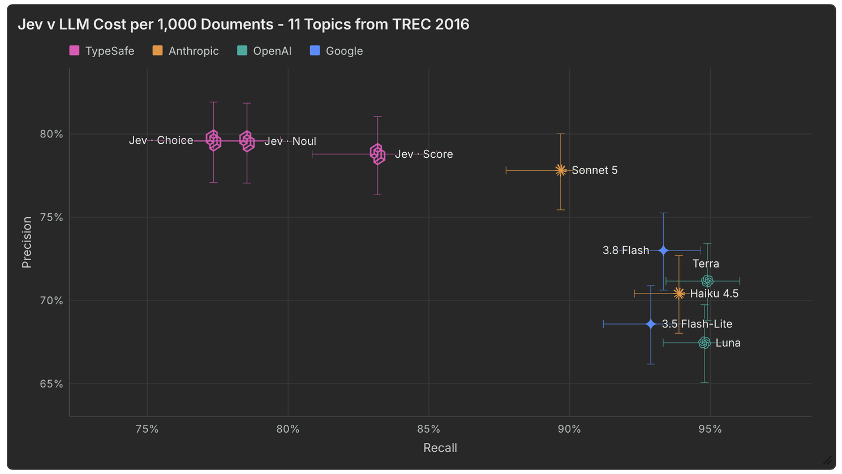
You can see that the results varied by question type, with "Score" performing best of the three "out of the box" question types. As a reminder, the criteria got one round of refinement on a separate calibration sample and were then frozen for every model, and nobody tuned Jev's 0.5 cutoff, so we consider these results a floor for what might be possible.

Speed
If you've seen other posts about Jev, this part shouldn't be surprising. It's really fast. Because a decision model like Jev does not generate text, it scores every question in one parallel pass over the document instead of writing its answer out one token at a time, which is where most of an LLM's latency goes. Below is the median round-trip time per document for Jev and the six API models to tag all eleven TREC issues in a single request. TypeSafe's launch post claims two orders of magnitude; in our implementation, over the public APIs with all eleven topics in one request, the gap was about one order of magnitude: 9 to 23 times faster than the six API models. One caveat on how we measured: the Jev, Claude and GPT figures come from a dedicated sample of 200 emails sent one request at a time, the Gemini figures come from timings recorded during the benchmark run with eight requests in flight, and everything was measured over the public APIs from one location. Read the ratios, not the milliseconds.
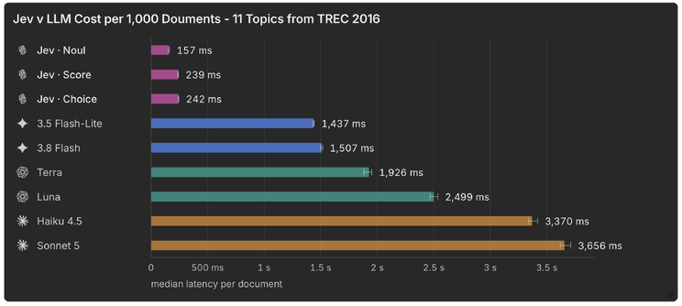
Faster? Check.

Cost
As with speed, Jev has a significant advantage here as well. Part of the reason is structural: Jev bills only for input tokens, at $0.042 per million, its output is free, and it does not generate text token by token. For this comparison Jev and the six API models were each asked all eleven topics in one request per email, and every cost is at the provider's standard list price with no batch, flex-tier or prompt-caching discounts. Below is the cost per 100,000 documents to review for the eleven TREC issues: about $16 for Jev (Noul $15.6, Choice $16.5, Score $18.1), against $124 for Luna, $210 for Flash-Lite, $444 for Flash, $610 for Haiku, $1,238 for Terra and $1,674 for Sonnet 5.
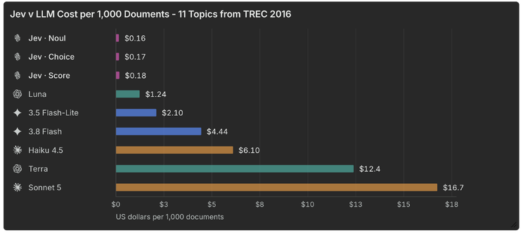

Stability
We also tested the stability, or determinism, of each model. We sent the same 300 emails through each model five times with identical inputs and counted how often two runs disagreed on a decision. Like humans, non-deterministic models can produce different outputs from identical inputs. We measured this for the LLMs and were curious how Jev would stack up. Here, Jev demonstrates significantly more deterministic behavior than its LLM counterparts, meaning outputs are more consistent between runs.
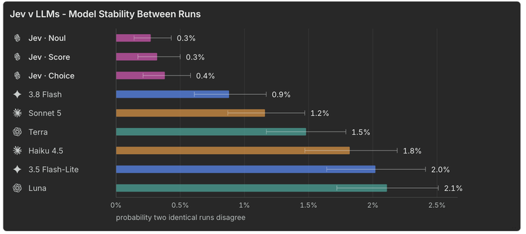
One fairness caveat: the LLMs ran at their default sampling temperature, and some of what the chart shows is a setting rather than a property of the model. At temperature zero, Haiku's disagreement rate falls from 1.8% to 0.4% and Flash's from 0.9% to 0.7%, while Luna (1.7%) and Flash-Lite (2.2%) barely move. Jev's three question types sit at 0.27% to 0.38% either way. So some of the LLM disagreement is a sampling setting a user can turn off, and some of it is not.

What might be possible
The three primitives leave a lot of room for creativity. We tested several composed configurations, where the answer to an issue is built from more than one question, with varying degrees of success. One strategy we call "facets" boosted recall to 89% while holding precision at 75% (with the same richness caveat as above); it costs more ($25.5 per 100,000 documents against $15.6 for plain Noul) because there are more questions per email, but it is still an order of magnitude under the LLMs. A Relevance Gate (an extra question, "does this email have anything to do with the matter at all?", multiplied into every issue) went the other way, to 70% recall and 82% precision, and averaging three phrasings of each question (the Three-Phrasing Ensemble on the chart) changed little, at 81% recall and 79% precision. No doubt, there is a lot of room for exploration and service provider differentiation here and the best approach will likely vary with each project.
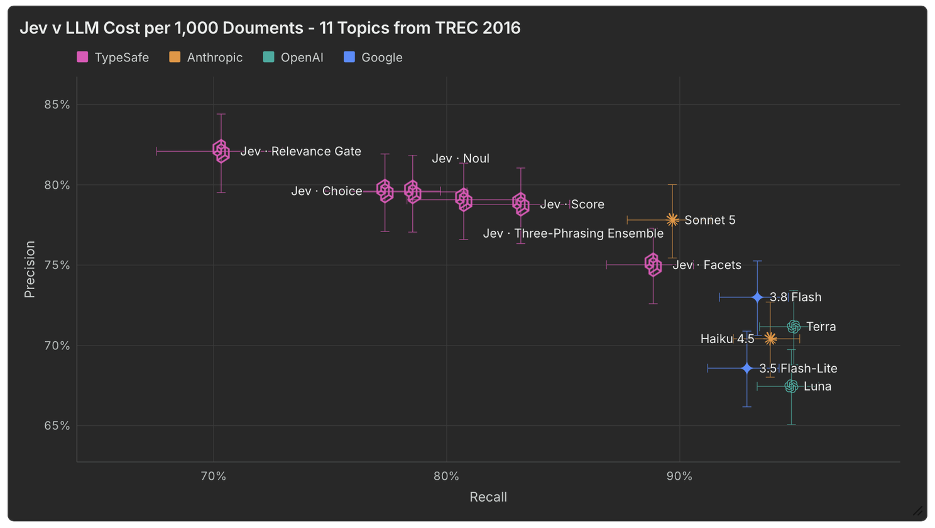
If Jev is able to make relevance determinations at scale, for about $16 per 100,000 documents, in a fraction of the time of an LLM, the opportunities extend far beyond relevance review. At those prices, all eleven topics on a million emails would cost about $156; the cheapest LLM we tested would cost about $1,240 and Sonnet 5 about $16,700. Jev could replace keyword search. Jev could enrich and accelerate early case assessment (ECA).
Outside of document review, Jev could show promise in quality control, citation checking, enriching large data sets, and doing many other use cases. A preprint from Carnegie Mellon (Yubo Li, Yidi Miao, Ramayya Krishnan and Rema Padman, "JEV-as-a-Judge: Accept When Confident, Escalate When Unsure," arXiv:2609.26550, September 22, 2026) found that, "comparing jev-as-a-judge with sixteen generative and reward-model judges, with blinded human adjudication, we find it within three percentage points of a state-of-the-art LLM judge." The same abstract continues: "Larger gaps arise when judgments require checking a derivation or resisting an elaborately written wrong answer."
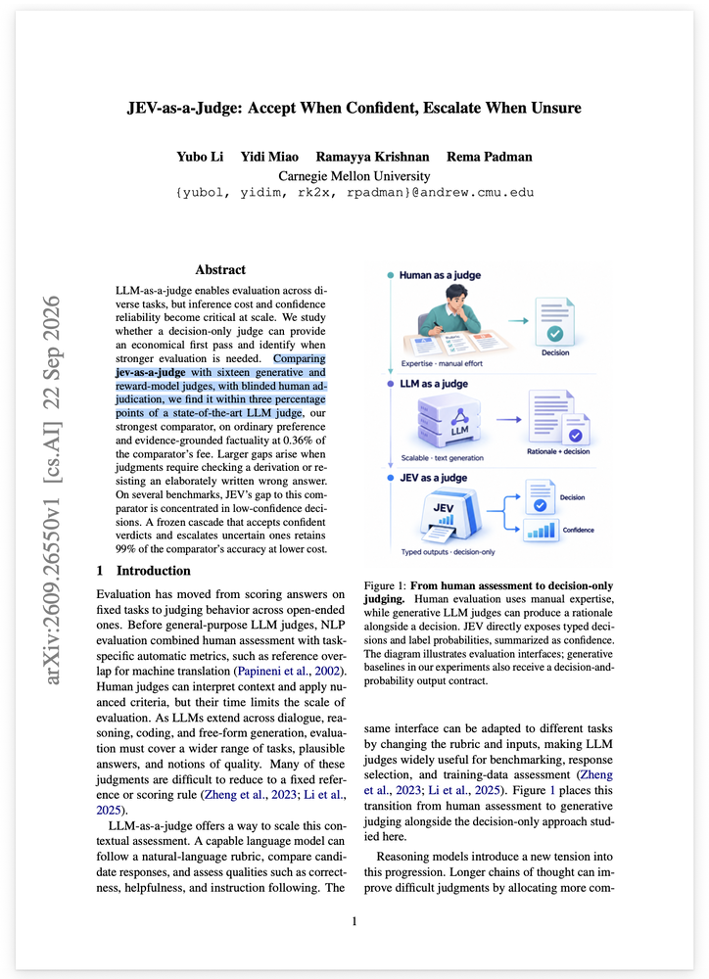

Limitations and Unknowns
Jev is designed specifically for classification and automated decision making. Unlike LLMs, it does not respond to user queries with written answers. TypeSafe's own docs say System One models "do not write replies, produce code, or generate explanations of their reasoning," and that a question needing "extended reasoning" should be broken up. Tasks like research, drafting or summarization, and every human-in-the-loop use (chatbots, copilots, coding agents), are better left to LLMs. Even for classification, Jev gives you a label and a probability and nothing else. Tools like Relativity aiR for Review return a rationale, considerations and citations to the text alongside the call; a reviewer can read why. With Jev, the "why" has to come from how you decomposed the question. Their docs also warn that accuracy "falls as the state grows with content unrelated to the decision"; our test documents were short emails, not long attachments.

Who should care about Jev?
Jev is not a SaaS eDiscovery platform. Jev is a new model that software companies like Relativity are presumably evaluating to learn more about what it is and isn't good at. If you're an applied scientist or developer looking to test a new model against your current baseline, it might be worth giving Jev a serious look. Today Jev is in early access through TypeSafe's own API and SDKs; there is a waitlist, and rate limits are still moving.

Conclusion
When it comes to relevance review, Jev may not yet be "better," but it is certainly "cheaper" and "faster," and, depending on the use case, may be "good enough." The results we've shared should not be treated as a verdict on whether Jev is viable for your workflows. But, at a minimum, we hope they add color to the conversation and spur more research and experimentation. As we used to say about LLMs, this is the "worst the technology will ever be." What a fun time to be in legal technology!

